 **Endt No. TA/S&M-CFA/184/2016-17/66 dated 23.06.2017.**

To

All the SSA Heads,

O/o CGMT, TS Circle.

Incentives to motivate the staff to increase growth of Landline and Broadband connection for taking necessary action please.

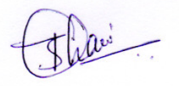

AGM(S&M), CFA

O/o CGMT, TS Telecom.